Contents

1. Introduction 6

1.1. Overview 6

1.2. Technology Implementation in AEC Sector 7

1.3. Smart City and Digital Transformation 7

1.4. Scope of Research 8

2. Literature Review 9

2.1. Control Room 9

2.2. Control Room in the Industry 9

2.3. Digital Twins 10

2.4. Components of Control Room 10

2.4.1. Cloud Service and Collaboration Platform 10

2.4.2. Visualisation – Immersive Virtual Reality 11

2.4.3. Visualisation - Dashboard 11

2.4.4. Visualisation - Real-time Web-based Model Viewer 11

2.4.5. Open API 11

3. Methodology 12

3.1. Use of available data, software, and service 12

3.2. Framework of Control Room in Construction 12

3.2.1. Data Layer 12

3.2.2. Data Services Layer 13

3.2.3. Application Layer 13

3.3. Source of Data 13

3.3.1. Model Data 13

3.3.2. Project Performance Data 14

3.3.3. Sensor Data 14

3.3.4. Statement of Ethics 15

3.4. BIM 360 16

3.4.1. BIM 360 Collaboration 16

3.4.2. Forge API 16

3.5. Microsoft Azure 16

3.5.1. Data Capture and Storage 16

3.5.2. Database Management 17

3.5.3. Streaming of Sensory Data 18

3.5.4. API Endpoint 18

3.6. Visualisation Techniques 18

3.6.1. VR 18

3.6.2. Dashboard 19

3.6.3. Web Viewer 19

4. Result & Discussion 20

4.1. BIM360 20

4.1.1. Benefits of functionality 20

Model Review: 20

4.1.2. Approval of workflow 20

4.1.3. Design Collaboration 21

4.1.4. Management of Issue 21

4.1.5. Comments & Feedback 21

4.2. VR 22

4.2.1. Case Study: Project Coordination & Training 22

4.2.2. Drawbacks 23

4.3. Dashboard 24

4.3.1. Case Study: Safety Data to identify critical safety record 24

4.3.2. Drawbacks 25

4.4. Web Viewer 26

4.4.1. Description of sensory data 26

4.4.2. Visualisation of sensory data 26

4.4.3. Functionality for Construction Professionals 26

4.4.4. Drawbacks 26

5. Limitation (500) 28

6. Recommendation (500 words) 28

6.1. Future works 28

7. Conclusion 29

8. Reference 30

9. Research Log 32

10. Appendix 33

List of Figure

Figure 1 Digitalisation Index 7

List of Table

Table 1 Technical Specification 15

Declaration

Abbreviation

Acknowledgement (to different software/ service provider)

# Introduction

# Overview

Architecture, Engineering and Construction (AEC) sector is one of the largest sectors in the global economy. There is about $10 trillion spent on construction-related activities over the world annually, which is equivalent to 13 percent of GDP. There is also 7 percent of working population around the world working for this industry (McKinsey & Company, 2017). However, the productivity of AEC Sector is lagging the global productivity by over 30% and 98% of infrastructure projects are over budget or delayed around the world (Changali et al., 2015).

As AEC sector is complex and dynamic in nature (Mohd Nawi et al., 2014), it consists of multiple disciplines and teams at various stages such as planning, design, construction, and operation. The parties are mainly client, designer, contractor, and manufacturer who are involved from the beginning until the completion of the project. Over the years, the project delivery practice among these parties are notorious for poor in collaboration such as isolation of working and inadequate co-ordination. As construction projects can involve thousands of work tasks which are interrelated, so if one individual task happened with quality and safety deficiency, it would significantly impact the progress and the budget control of works in future stages.

Apart from that, the information management in construction is not effective enough. The AEC Sector is labour-intensive and generates enormous amounts of information including calculation, drawings, project reports, tender documents, ...etc which are produced in the planning stage to the operation stage. According to a research in China (Xu & Luo, 2014), it has identified and discussed many consequence on the poor collaboration and information transfer among different parties, such as the loss and inconsistent of information caused by fragmentation of parties and unorganised information system. There is a comprehensive statistic of two typical sites in middle and North China, it shows that around 43%, 12%, 3% of the project time lost due to inconsistent information, dislocation, and ambiguity respectively on a construction project in average.

Health and safety deficiency are also one of the main concerns as compared to other sectors. The AEC Sector has long been recorded with the highest number of death and accident rate compared with other industry sectors globally. For example, it is about 79,000 construction workers across all industry suffered from health issue by working (new or long-standing) and 30 fatal injuries in 2018/19 (HSE, 2019). There was also about 2.1% of construction workers suffering from musculoskeletal disorder that they noticed that they got it during working. The rate is statistically significant than the rate for workers of other industries (1.2%) [ibid].

# Technology Implementation in AEC Sector

As the AEC sector is embracing the digital age, the processes involved in the design, construction and operation should be enhanced by technologies dealing with value-added monitoring of data and optimisation of engineering systems. However, the AEC Sector is notorious to adopt new technology and digitalization much slowly compared with other industry. The digitalization index of construction is very low as shown on below figure (McKinsey, 2015).

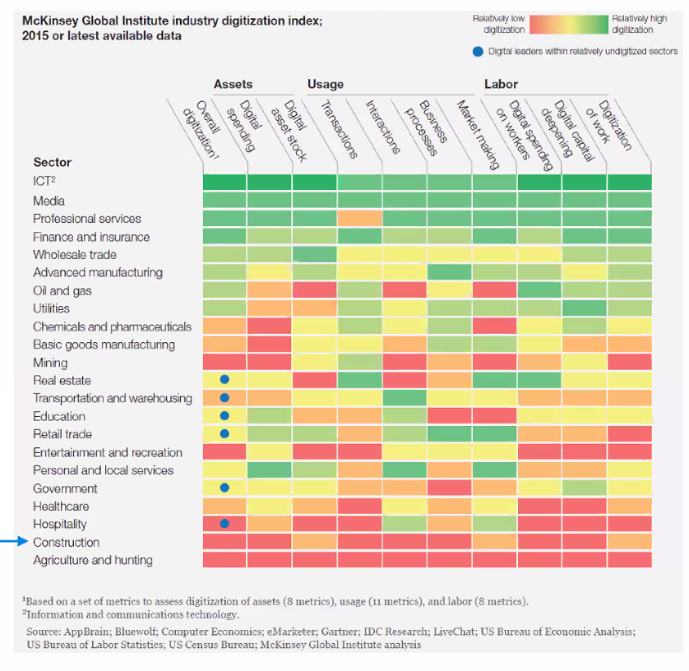

Figure Digitalization Index

Although the sector has recognised the need for change and adopted many technological solutions such as Building Information Modelling, Virtual Reality, ..etc , they are fragmented point solutions and disorganised (Woodhead et al., 2018). To improve the construction project delivery by technology with a long-term advantage, a “planned IoT ecosystem” approach rather than combining different “point solutions” is recognized. This system should be with high connectivity between hardware, software and making key decisions based on data (ibid).

Besides, as the explosion of global pandemic COVID-19 is accelerating the development of digital transformation in different industry. With unprecedented consequences such as the disruption of manufacturing and supply chains, the mitigation to the impact by COVID-19 requires new approach of working and forms of collaboration such as remote working among team members to increase overall resilience of the business by using technology.

# Development of AEC Industry under Smart City Paradigm

Nowadays, the smart city paradigm is embraced over the world. It proposed that the technology developed should be citizen-focused, the developer must understand their citizens and develop appropriate technologies which will be beneficial to them. This framework of smart city research is described as “citizen centric” (Lara et al., 2016). This citizen-centric value defines the initiative Project 13 in AEC industry, which aims to develop a new business model for delivering high performing infrastructure to the ultimate user (i.e. the citizen). There is an ‘Integrator’ character which can be a single company or a collective party which plans and delivers the infrastructure programme, manages the suppliers and advisors, oversees design, construction, maintenance and operations as requested by the owner (Engineers, 2018). Most importantly, it pointed out that the Integrators should bring together capabilities to deliver effective solutions through production systems and enables a platform approach to deliver the project under the “Integration” pillar of the five pillars in the initiative (ibid).

Regarding to this, an integrated platform such a control room platform should be developed so that we can effectively control and get insight from the data generated during the construction process to improve the project delivery.

# Scope of Research

The major scope of research of this study is as follows:

* Explore why the Control Room can help to improve the project delivery in AEC industry and the framework of it

* Explore how the control room to give insight and improve the project delivery based on available collaboration tools and visualisation techniques in the market
* Explore the challenges and improvement on a control room platform based on the evaluation on current available solution

# Statement of Ethics

All the data used in this dissertation do not contain any personal information. Therefore, no ethics approval was required.

# Literature Review

# Control Room

The control room was originated in 1920s, which is for production control and monitor the physical facility in a central space (Bennett, 1993) . In 1970s, the launch of Apollo 13 program by NASA make use of the control room for monitoring the outer space condition (Jarrett Hendricks, 2020). The engineers on the ground control room needed to response the changes swiftly to the space vehicle and the astronauts exposed to the extreme conditions in outer space. Later, NASA identified that they can no longer make corrective decisions based on the original modelling method because the actual module had subjected to significant changes due to the exposure under extremely hostile environment. It was necessary to update the original modelling method so that the actual state of the module could be closely simulated. As a result, they used the “pairing technology” to simulate the outer space with the mathematical models so that the engineers and different professional could collaborate in the control room on ground and made decision based on that mathematical model (ibid).

It shows that the framework of the Control Room approach as follows. First, it should be a platform which can enhance collaboration. Second, the model should be with protocols that allow storage, exchange, process the information obtained from the physical facility. Third, it should include digital models that visualise and analyse various data obtained the physical facility. This framework of control room is correlated to the concept of digital twin, which various industries are embracing.

# Development of Control Room in other Industries

**(collaboration, data visualisation, process, analysis)**

With the help of development new information generation and communication technologies, such as Internet of things (IoT), cloud computing, big data and artificial intelligence (AI). The digital twin has greatly developed in different industries nowadays. Digital Twin is ……

In the product manufacturing industry (Yi et al., 2020), the product digital twin acts as a single data source for the vendors to collaborate each other throughout the product lifecycle such as product design, process planning, product assembly, product use and maintenance. In a assembly shop-floor scenario, data visualisation and integrated management of shop-floor data based on digital twin is achieved. For example, the assembly shop-floor digital twin is composed of shop-floor production elements’ geometric models and physical models such as shop-floor model, production line models, assembly station models, manufacturing resource models, product models, and environment models. These 3D geometric models are constructed by Pro/E, CATIA, SolidWorks, AutoCAD, etc. Besides, methods like finite element method (FEM) and boundary element method (BEM) can be used to simulate the physical functions and performance of the elements (ibid).

In the financial industry, the head of compliance control room of a bank in Africa pointed out that the awareness of using the control room function as part of the larger compliance function has raised sharply in the financial services industry (StarCompliance, 2019). The purpose of the Control Room in this case is to monitor the sensitive corporate information flow from a multi-service financial institution.

Control rooms can act as a company’s nerve centre to monitoring the deals data such as mergers and acquisitions, equity offerings, debt offerings, …etc. The deals themselves are very complicated and generate enormous amount of data that must be monitored closely to ensure the deal data can be organized, recorded, and analysed. There is extremely little room for error for the deal data (ibid).

It shows that …..

How should be a control room in AEC industry:

Recent technological development in AEC Industry

On the side of construction stage for infrastructural projects, it generates enormous amount of information. A control room should be able to enhance project management to reduce risk of project delay, within budget, and minimise contractual implication as well as health and safety of workers as they are susceptible to hazardous situations. The Control Room can give insight to the project stakeholders on all aspects of health and safety before and during the construction works and allocate the resources and planning the project schedule effectively.

# Recent Development of AEC Industry

Good good … BIM, IoT to …..--> digital twin

In AEC industry, many professionals embrace the use of Building Information Modelling (BIM) with the adoption of Digital Twin paradigm to form an integrated approaches on micro level as construction site and macro level as city districts (Boje et al., 2020). Many studies related to smart cities and the AEC industry consider BIM plays an important role of the Digital Twin as it acts as the source of data. BIM act as a semantically rich 3D model for the Digital Twin to use in other applications such as formulating parallel oﬄine and online simulations such as health & safety of a working environment (ibid).

These literatures have pointed out that the control room should utilise digital twin as the basis, using sensory data as the source of real-time time and it should be linking with the BIM model in the AEC industry. However, as they just pointed out the conceptual framework and there is less organised research on how these control room solutions should be implemented, the technical challenges and how it works practically. For example, the details on using what types of sensors, cloud services and how to make best use of them are omitted. There is less study to evaluate the functionally and identify the requirement and limitation and whether it is easy to adopt this type of solution in the industry.

(Read the reference by Oliver - Living with a Digital Twin)

# Components of Control Room

Regarding to the above-mentioned gap, the practical application framework of the control room is outlined as below and the author will consider how to enhance collaboration between project team members and get insight from the data by different data visualisation techniques under this framework.

(could be improved with reference to some current industry examples and a little wider reading in each of the areas you chose. In particular, expand on how they relate to each other)

# Cloud Service and Collaboration Platform

The control room should be a cloud-based common data environment and a centralised collaboration platform to foster the collaboration and information exchange between different disciplines.

One of the examples on the market is BIM 360, which is developed by the cloud service Amazon Web Service. It allows easy access to all project information from anywhere. Information like Drawings, models and other documents uploaded during the design phase can be continuously developed into the next phase such as supporting requests for information (RFIs), submittals, inspections.

In addition, cloud computing changes the traditional way of businesses to manage IT resources, which the services such as servers architecture, databases, analytics and business intelligence over the Internet (“the cloud” ) and ensuring data security (Microsoft, 2020). Cloud Computing also eliminates the requirement of using local hardware to handle and process data, thus no need to pay extra cost to buy hardware with high computation power (Stergiou et al., 2018).

Besides, traditional tools such as email, project management software and telephone are just one-way communication activities. They lack the real-time collaboration elements which is for connected engagement, discussion and approval process (Levine, 2016). If different parties in the project can submit updates of information on a simple and real-time manner on a single platform to create a single source of truth, it will be easier for all project team members as one and remain on the same pace as the project proceeds, so it would not make the progress delay in terms of scheduling and over-budget due to rework.

# Visualisation – Immersive Virtual Reality

Immersive Virtual Reality (VR) can give the user feel like physically presenting in a computer-generated environment simulating places in the real or imagined worlds. It is common used in the education and training purpose by its potentials of provide an interactive and motivated environment (Freina & Ott, 2015). Besides, many publications have identified that VR technologies have been implemented to enhance safety in many areas (Alizadehsalehi et al., 2019), such as risks identiﬁcation, workforce training, skill transfer and ergonomics in the AEC industry (Li et al., 2018). While VR can also be used for meeting with team members to work together within a 3D model for discussion, which is benefit for remote working (Brandon, 2020). All these literatures showed that VR device is an effective tool for enhancing the interaction between human experiences and building environments.

# Visualisation - Dashboard

Dashboard visualisation is a cognitive tool to improve our “span of control” over the business data. This help the user to identify trends, patterns, and anomalies from the data. Managers can figure out the reason about what they observe and as a guideline for them to make effective decisions. It also let non-technological users to combine multiple data sets easily to customize a dashboard and generate data visualizations. Besides, Key performance indicators (KPIs) is commonly used to benchmarking and compare performance by meeting both strategic goals with a dashboard in different industry. Construction industry can also make use of the objective benchmarks and to measure excellence across the industry. The analysis results can help to improve the building processes and risk identification for project delivery. It is the topmost priority for Project Directors, Project Engineers and any other person responsible for planning management to implement a better planning process by having a clear view of the project’s status.

# Visualisation - Real-time Web-based Model Viewer

As suggested by (Boje et al., 2020) , Digital Twin should be based on a semantic web approach to accelerate digitalization by narrowing the gap between the physical and virtual world. Semantic web approach is to enable IT systems to process information by connecting web sites and data resources such as IoT devices so that the relationships and dependencies between pieces of data can be recognised (Keil et al., 2019). As a result, a web site approach to link the digital model data and the data from IoT device will be investigated.

# Open API

Under the context of smart city, the availability of information can create opportunities to get insight from the city's activities through modeling and analysis of data from different domains (Belizario & Berardi, 2019). This smart data solution can be used to get insight and able to manage cities data strategically (ibid). As a result, the Control Room should consist of a common data exchange standards and open Application Program Interfaces (API) for third-party developers to develop external applications (Woodhead et al., 2018). It motivates more developers to improve the functionally of the entire control room system and make good use of the data.

(You mention open APIs but what about Open Source technologies? Are there viable options or are there reasons that proprietary solutions might be preferable)

# Methodology

# Use of available data, software, and service

This study will make use of services and software currently available on the market to develop a prototype for the Control Room system and evaluate its usefulness with the available data. Originally the author intended to invite different construction professionals to use these applications of the control room in this study so that more feedback and comments from different perspective. However, under the current disruption by the COVID-19 pandemic, there is a great disruption on everyone form of working and working time, so it is hard to carry out such activity.

As a result, the functionality and visualisation techniques of the system will be evaluated by the author himself. The usefulness of all the software and services will be evaluated based on the author’s personal experience such that a clear view on how a Control Room should be developed on the perspective of collaborating, information management, analysis and visualisation of the data can be discussed further.

# Framework of Control Room in Construction

Available service and software in the market has been allocated into different layers of framework for the Control Room as below figure. It composed of 3 layers which are the Data Layer, Data Services and Application layer.

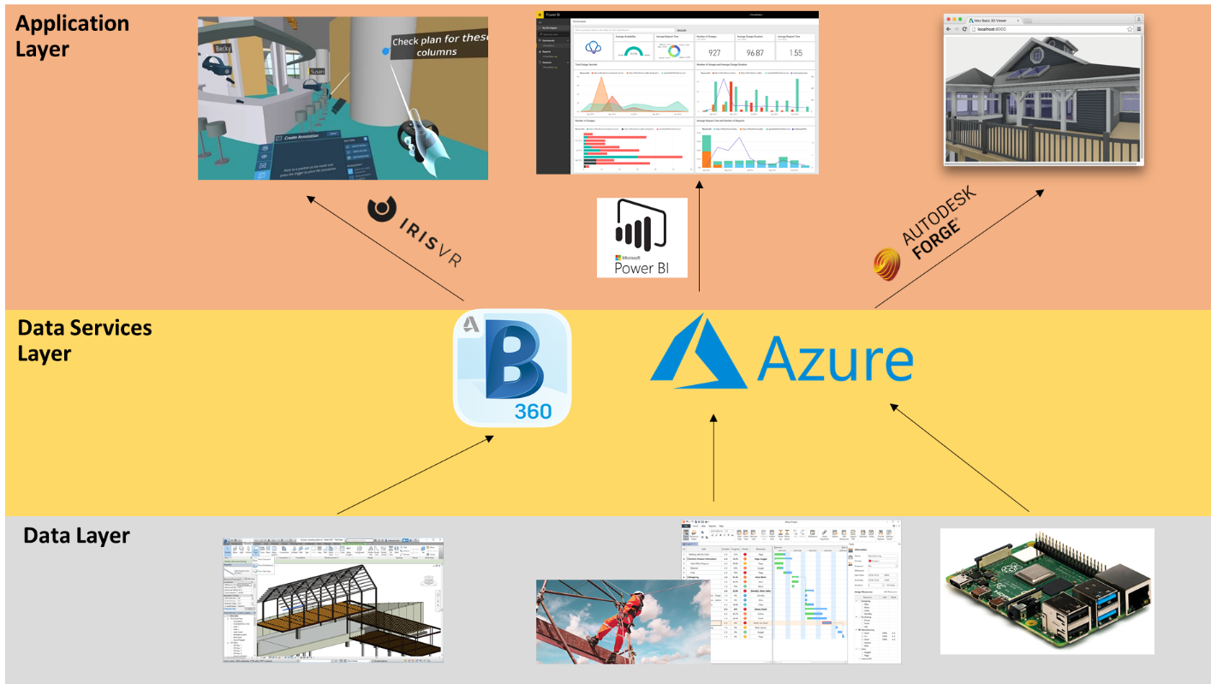

# Data Layer

Each of the component (from left to right) in the data layer represents an aspect of the construction site to reflect the performance.

1. Model data: the virtual model of the physical configuration of the building or infrastructures
2. Project performance data: Safety and Progress related data
3. Sensory data: Working condition of the construction site

# Data Services Layer

It forms the core part of the Control Room. The model data can be published to the BIM 360 cloud platform for collaboration so that different project team members can work remote and modify the model data on a single source of environment. Besides, the Microsoft Azure Services provide a platform to storage and process the data. The project performance data and sensory data will be stored in a SQL Server database which is created with Azure Services. The data can be retrieved to feed into the elements in application layer for visualisation.

# Application Layer (Reason why choose them)

The Application layer is for data visualisation. Model data in BIM 360 will be visualised in VR environment with the software “Prospect” developed by IrisVR. The project performance data will be visualised as dashboard by Microsoft Power BI. While the sensory data will be visualised with the model data on BIM360 by Autodesk Forge API. There details will be discussed in Section 3.3 to 3.5.

# Source of Data

A case study of constructing a residential house will be used to demonstrate the application layer of the Control Room. All the data available will be modified to fit in the novel of the case study.

# Model Data

The model data is a digital prototype of a residential house, which is a template file provided by Autodesk Revit 2020 with format of “.rvt”. The 3D model can be visualised as the below figure:

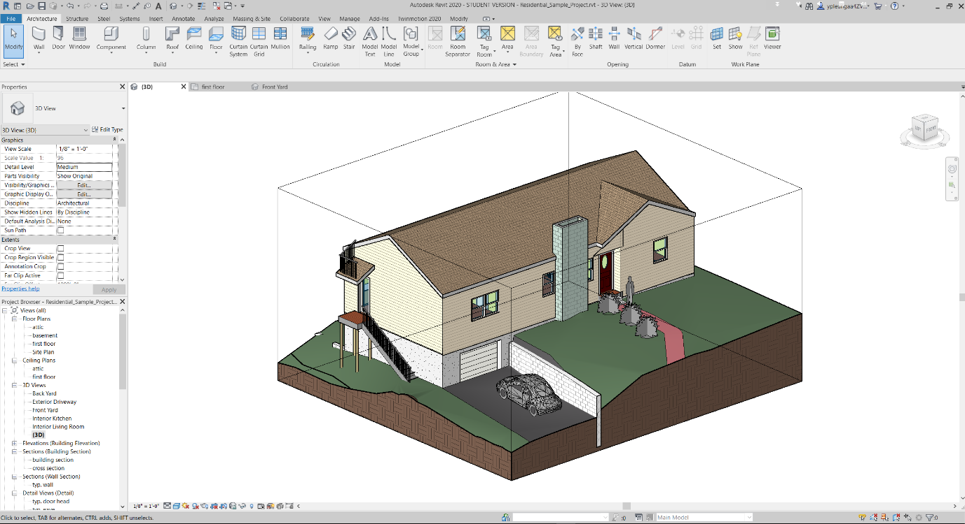

The model contains objects data relating to the architectural and structural elements. All objects in the model contained information such as object name, type ID, furniture name, material information and major dimensions in object property. All the model data would be processed by Autodesk Revit first and would be published to BIM 360 online to simulate the collaboration between the structural and architectural team.

# Project Performance Data

2 Datasets of project performance data used for this study is taken from the data provided from the ‘Project Hack’ hackathon organised by Project Data Analytics Community (better reference).

The first one contains all incident record of a construction site ranges from 2012 to 2017, it includes detailed information with 1023 rows and 26 columns, such as date of accident, accident category, nature of injury and damage classification and type of contact.

The second one contains the handover record for different rooms and area of a construction site, it includes information with 193 rows and 16 columns, such as code for the room/area, handover date for stages 1-5 and handover status.

# Sensor Data

Low cost microcontroller Raspberry Pi (RPi) has been selected as the prototype of IoT devices to capture the construction environment data. RPi is a Linux-based platform. It is a credit card-sized computer and can be as an alternative of a desktop computer. As it is low cost and support different operating systems, it is suitable for ranges of projects such as acting as IoT device. The version used in this study is the Raspberry Pi 4 Model B which is newly released on the end of May 2020. The RPi can connect with local area networks with WIFI and transfer the data received from the sensors to Microsoft Azure IoTHubs services, which will be explained in Section 4.4.1. The technical details are given in the below Table:

Table Technical Specification of Raspberry Pi and Sensors

|  |  |  |  |
| --- | --- | --- | --- |
| **Sensor** | **Data to capture** | **Image** | **Technical Data** |
|  |  | Raspberry Pi® 4 B 4 GB 4 x 1.5 GHz Raspberry Pi® | Conrad.com |  |
| SHT20 | Temperature,  Humidity | SHT20 溫濕度傳感器模組I2C 通訊- 台灣物聯科技TaiwanIOT Studio |  |

Figure to show final configuration of the Raspberry Pi with sensor installed.

Under the current disruption of COVID-19, it is hard to find an actual construction site for capturing the data for our study. As a result, the sensory system had installed on a local factory which manufactures hanger in Hong Kong to simulate the working condition of a construction site and the ability of the sensor to collect the empirical data. The usable area of the factory is around 75 sq. feet and height 12 feet. One worker will be work in this factory to keep on monitoring and maintenance the machineries which produce the hangers and processes the raw material inside the factory. The working environment will be impacted when the machineries are operating. As a result, it is a reasonable location to be chosen to simulating capturing data in a construction site.

-> general layout of site (photos)

->how sensor set up and collect data in the factory (Photos)

# BIM 360

# BIM 360 Collaboration

BIM 360 will be used to simulate the collaboration function of a control room. The modules of this cloud platform such as Document Management, Design Collaboration and Project Management modules will be used for exploring the functionality on multi-disciplinary coordination on all project information. Drawings, model data and relevant files uploaded on BIM360 support version control will be uploaded to the module Document Management. Design Collaboration module can show the different drawing packages created by different parties on a timeline and will allow them to decide whether to consume that package for their further amendment. The data also supports requests for information (RFIs), submittals, inspections and more will the module Project Management.

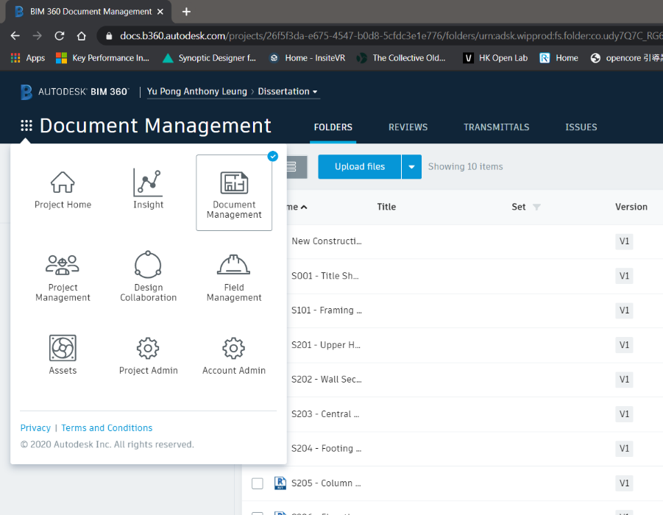

# Forge API

To retrieve the data from BIM 360 to the web viewer application, the Autodesk Forge API has been used. It comprised of multiple API’s, each one dedicated to a specific group of tasks related to the Autodesk cloud ecosystem. The data in BIM360 such as model data, checklist, issues and so on can be further developed for automated processes, workflows and data visualisation. All the available API can be explored on forge.autodesk.com.

# Microsoft Azure (Compare with AWS)

Microsoft Azure offers cloud service in three main categories: Infrastructure as a Service (IaaS), Platform as a Service (PaaS), and Software as a Service (SaaS). PaaS will be focused on this study. Platform as a service (PaaS) is a cloud-based development and deployment environment, with resources to deliver our own applications. PaaS not only includes the elements of IaaS such as servers, storage, and networking, it also provides middleware, development tools, business intelligence (BI) services, database management systems, and more. It is designed to support the full development of the lifecycle of a web application like building, testing, deploying, managing, and updating. PaaS enable the author to manage the underlying application infrastructure and middleware of the development tools and other resources easily. Besides, Azure cloud services offer a free tier one-year subscription to their services for students. The services can also be purchased as pay-as-you-go basis.

# Data Capture and Storage

Data has been sent over to Azure for interception and storage in a database for management, analysis and visualisation. For the sensory data, the sensor with the microcontroller Raspberry Pi (RPi) act as a node and registered as an ‘IoT devices’ in Azure. By using the IoTHubs services as the gateway, the data can be further processed as below figure referenced from the Microsoft Azure Cloud.

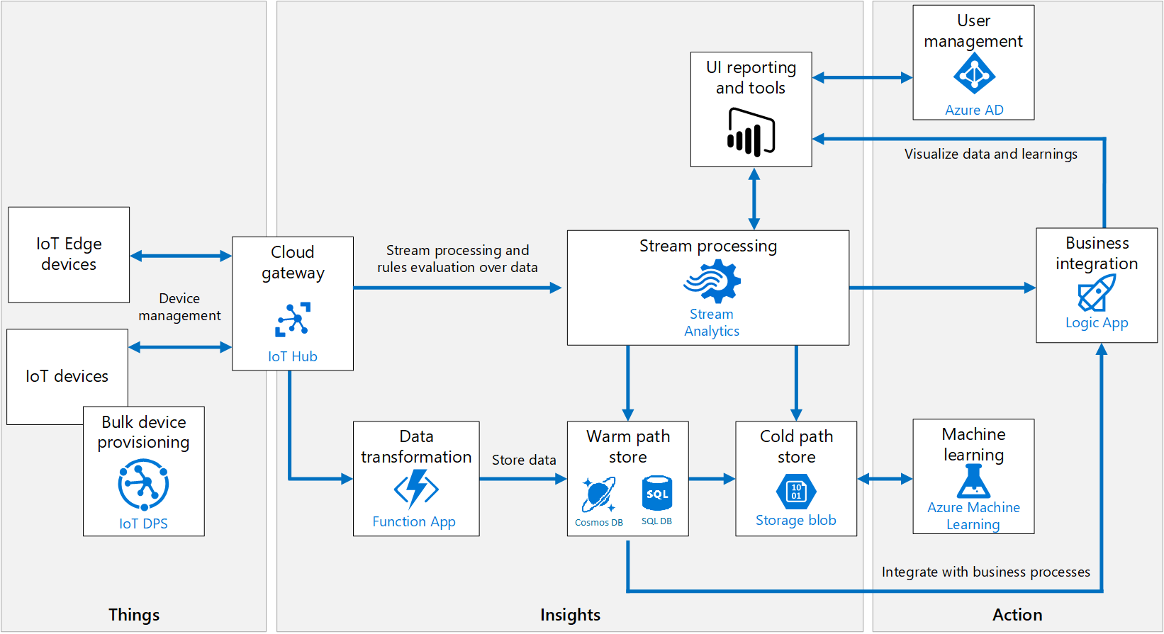

Figure Azure IoT Ecosystem

# Database Management

Azure SQL Database is a fully managed PaaS database engine that handles most of the database management functions such as upgrading, patching, backups, and monitoring without user involvement. With Azure SQL Database, a highly available and high-performance data storage layer for the applications and solutions can be created. It also allows the process of both relational data and non-relational structures, such as graphs, JSON, spatial, and XML. Data in file format like .csv can be moved to an Azure SQL Database using a Bulk Insert SQL Query.

A python script (Appendix XX) was used to insert the performance dataset which is in .csv format. It established a connection to the SQL Server with the required credentials and perform inserting to the database. Python Libraries such as panda and pyodbc will be used for data processing and building connection with the SQL Server.

|  |  |  |  |
| --- | --- | --- | --- |
| **Table Name** | **Field** | **Type** | **Description** |
| SAFETY |  |  |  |
| PROGRESS |  |  |  |

# Streaming of Sensory Data

Besides, Azure Stream Analytics is a real-time streaming engine that is designed to process high volumes of fast streaming data from multiple sources simultaneously.

Once the relationships between input sources RPi in IoTHubs and output sources such as SQL Database has been formed, it will trigger the streaming of real-time sensory data from IoT device to SQL Database. The Python script (Appendix xx) has executed on the RPi to connect with the IoTHubs. RPi is set to send data every 10 seconds. The parameters obtained are the microcontroller device id, timestamp, temperature, humidity, CO2_level and PM2.5_level. These parameters are added as a new row in the Azure SQL Server database.

In summary, there are 3 tables which are the safety data, progress data and sensory data of the data layer for the control room.

|  |  |  |  |
| --- | --- | --- | --- |
| **Table Name** | **Field** | **Type** | **Description** |
| SENSORY |  |  |  |
|  |  |  |
|  |  |  |

# API Endpoint

Azure App Service is an HTTP-based service for hosting web applications, REST APIs, and mobile back ends. Node.JS application has been developed to retrieve the data from the SQL Server Database. The script is on Appendix XX. It defines an URL endpoint for triggering GET request from the tables in SQL database and returned as a JSON object for live data visualisation and analytics. Data can be retrieved from these API for the visualisation applications. The API documentation can be found on the studies GitHub page.

# Visualisation Techniques

# VR

The plug-in of Autodesk Revit called “Prosepct” which is developed by IrisVR will be used for VR visualisation, the model data in BIM360 can be opened in Revit and the model will be converted for VR visualisation by using this plug-in. The 3D Views of the model can be imported directly into VR and automatically become viewpoints. It can create a narrative for the VR experience which is in 1:1 scale. The immersive VR headset Oculus Quest will be used for this study. It is a completely wire-free, PC free and with all the sensors built in. The specification is as follows:

|  |  |
| --- | --- |
| Display panel | OLED |
| Display resolution | 1440 x 1600 per eye |
| Refresh rate | 72Hz |
| CPU | Qualcomm Snapdragon 835 processor |
| RAM | 4GB RAM |
| Battery | Lithium-ion battery with 2-3 hours playtime, depending on what you are playing |
| Degree of Freedom | 6 degrees of freedom head and hand tracking |
| controllers | Two touch |
| Weight | 571g |

# Dashboard

A dashboard application was built on top of Azure SQL Server Database to provide data visualisation and analytics. Microsoft Power BI will be used to visualise the construction performance data as a dashboard. As Power BI can get data from different source, data can be retrieved from Azure SQL database after the connection has been set up. Whenever the data has been sliced or another field has been created for visualization, Power BI will make a query to the database to get data.

# Web Viewer

The Web-Application was to provide a plug-n-play tool for user from any background to understand the working environment of the construction site with the visualisation of a digital model and sensory data. The viewer application aims to visualise the model data in BIM360 by means of the BIM 360 API of Forge API. The viewer application is a WebGL-based, client-side JavaScript library for 2D and 3D model rendering. The model data will be first translated to SVF using the [Model Derivative API](https://forge.autodesk.com/en/docs/model-derivative/v2/) of BIM360 APIs. Once the process has completed, the viewer will be able to visualise these translated files.

Besides, the real-time sensory data will be visualised with JavaScript library D3/Chart.js on the page with the model. New data streams can be added dynamically. The chart will automatically update the new data series into the available space in the SVG.

Then, the website will be deployed to Azure. (details…..)

(Github link: )

# Result & Discussion

(Put video and the link of the Control Room)

(The benefit and limitation of features should be reflected in your case study with your data, focus on 3 or 4 key observations that you want to discuss and explain why they are important on the scaleability or implementation of this kind of technology.!!!!)

# BIM360

# Document Management

This cloud platform is easy to adopt and not affecting the user’s traditional working style. Since many constructions professional afraid using new technological solution will have long learning path and not willing to pay extra time to use these tools, but this tool has avoided this problem. For example, after the structural team members have modified that model such as adding additional structural elements like beams, columns and walls on the local desktop software Autodesk Revit, the model can be uploaded to the “Document Management” module of BIM 360 by just a one-click button in the local software Revit. It provides a way that different team members can keep their traditional working method such as working on the local software on their computer and provide an easy way to synchronise what they have done in the cloud.

It also provides a good management of information management. The “Document Management” module provides a version control for model data; it shows all the record of what have been updated in each version and tracking who have modified the model data. Besides, the model data can also be compared together and the difference between them can be highlighted. It provides a good way for the managers to easily identify how the design has been changed due to construction constraints, which raise the awareness to the update of information.

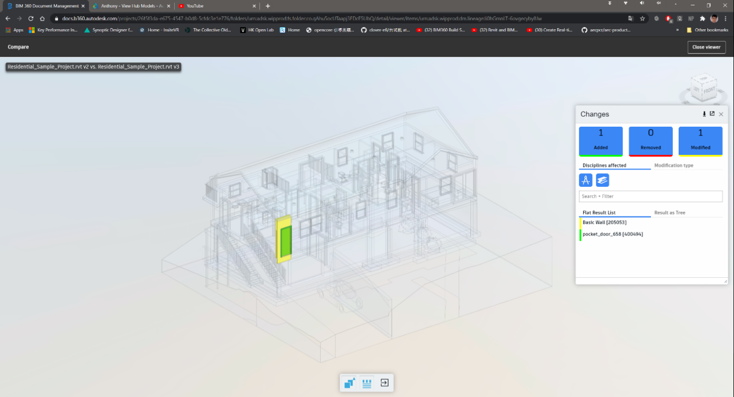

# Approval of Workflow / Management of Issue

Besides, it provides a function to keep track on the approval of workflow. Different Team member can initiate different workflows. For example, after the project engineer in structural engineering team has updated the model and would like to submit to other designated team members to review, he can select the model and choose the desired workflow and assign to other team members for review. After the review has been submitted, an email notification window will be automatically sent to the team members. Then, the reviewer can make markups with the standard markup tools and add comments to the model. And the reviewer can submit its review to the final approver for final approver. Apart from workflow approval, there is also a Request for Information (RFI) function provided by the “Project Coordination” module for different team members to raise queries and ask for clarification, which works similar to the workflow approval.

These processes are good for quality assurance on the engineering design document and provide a way to manage the information effectively. As it can record who have already received the notification for review the document and who need to answer the queries by other team members, so they should act on time. It can increase the productivity in the project delivery. (charts)

# Design Collaboration

Besides, the “Design Collaboration” module shows a good enhancement on the collaboration of team members and the information management. For example, the structural team members can make use of the ‘Link Revit’ function in the local desktop software Revit to consume the finalised model from other team members such as the architectural team. After that, the structural team can design the structural elements such as beam, columns and walls based on that model. After that, the structural team can synchronize and publish the finalised model to the BIM 360. Later, the structural team can create a package in the timeline as shown on below figure so that the packages can be shared to other team members to consume this model and keep on modify it. This is the concept of the design collaboration loop which fully utilising the ISO19650 collaboration procedure to provide a continuous and smooth handover of the model data between different team members, which enhance the collaboration and information management.

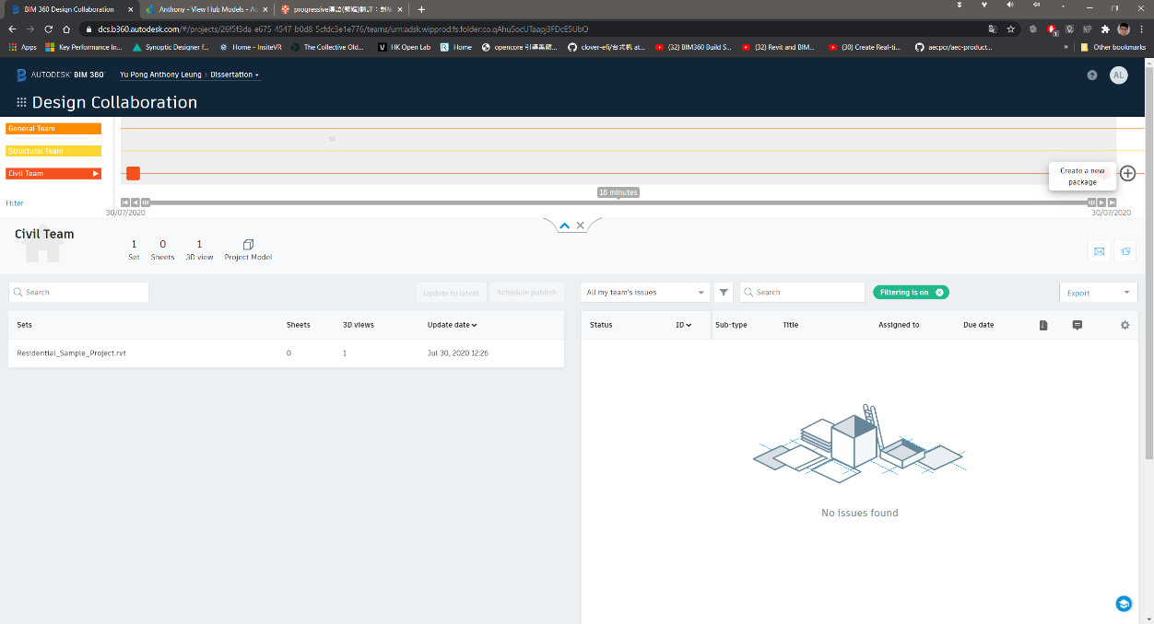

# Comments & Feedback

All the modules in BIM 360 is effective for the information management and collaboration of team members. However, the “design collaboration” module is a bit complicated and it created multiple model data files which may lead to confusion. For example, after the publish of the model data by one team member to the BIM 360, the model will be saved in the folder of “WIP (Work in Progress) folder”, which is created automatically under the work breakdown structure of the design collaboration module. Besides, as the user need to create a package to share to other team members, the model data will be saved in “Shared” folder for sharing to other team members for consume. And finally, after the model has been consumed, the model will be saved in the folder named “Consume”. As a result, multiple model data files have been created by using this design collaboration loop concept and it may make confusion to the beginners that they do not understand which model is the latest one and which model they should be used if they are not familiar with the design collaboration concept.

Besides, due to the legacy format of model data, it cannot be dynamically updated the model data in real time. For example, the structural team members can view what the architectural team has been updated once architectural team have shared their completed model on the BIM 360, instead of view how the architectural part of the model being modified in the real-time when the structural team access to the model. They still need a hold point that all members to check and discuss how they would modify the model so that the elements would not be crashed and compromised the design.

(It set an good an example of how these function to be built in the control room platform)

# VR

# Case Study: Project Coordination & Training

By using the VR visualisation to the model data, different team members can fully immerse in the 3D models data. It gives a great perception for the project team members to understand how the construction environment would be instead of imagination from the traditional drawings. Team members can explore how a proposed residential house will feel and function through inspecting the details, walking though different rooms and areas, and teleporting from one location to another location instantly.

Different team members can carry out remote VR design review meeting to collaborate each other and understand the need other team members. They can make use of the utility features such as measurement, markup tools, object details and sectional view for the user to present their idea during the remote meeting effectively. For example, the building service team members can use the markup tool to add annotations and comments on the ceiling of a specific room so that the structural team members can adjust the setting out of the structural beam to avoid crash with this building services utilities during VR inspection.

After they all have agreed how they would modify their design or the construction sequence in the VR inspection, team members can combine with the use of design collaboration module in BIM360 to consume the BIM model from other team members for further modification. As a result, different team members can modify the model effectively and avoid crash of elements or design fault, which greatly increases the productivity. Combining the VR visualisation method can greatly unleash the potential of the collaboration tools of the Control Room.

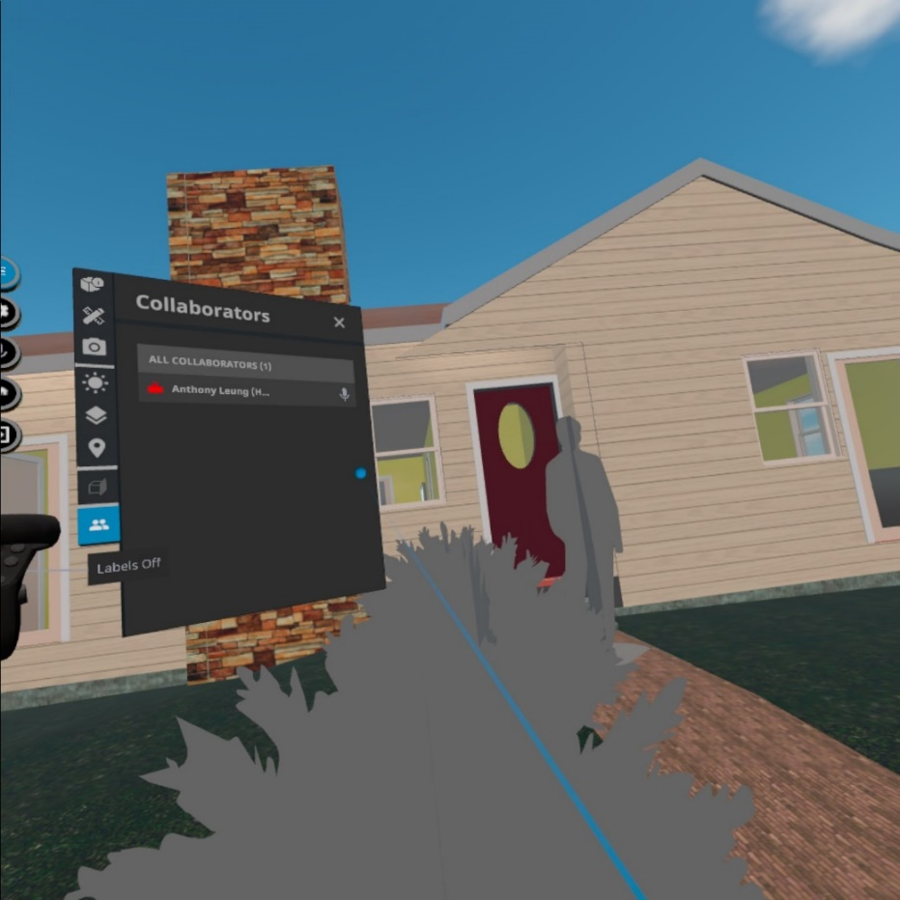

Besides, it is a good tool for using in safety training purpose. As the user can visualise the model from it very beginning to the final completion stage. All the safety hazards during the construction can be identified and find out the exact locations with the high risk of safety deficiency such as confined space, locations which easy to fall from height. For example, some location such as the outer stair from the model which is above ground for xx meters and at the edge location, which is highly susceptible to the hazard of falling from height. As a result, the managers can arrange special training and pay more attention during the construction of that stairs.

# Limitations

VR can provide a great immersive experience for the users. The “Prospect” provides 14-days free trial with all the navigation and utility features, which is beneficial for the AEC companies to have a trial on using VR. However, the subscription cost is quite high and often exists as a separated plug-in or services rather than integrated with the collaborate tools. It made individual need to pay extra cost to buy this service to use, which lower the motivation for the construction professionals to adopt this technology. According to two services providers like “IrisVR” and “the Wild” which can function as a plug-in with Autodesk BIM360 and Revit. Their monthly subscription is about $225 USD and $295 USD, which is not an affordable price for some company especially some small size company to adopt this solution.

Besides, the add-on integrity of the “Prospect” should be improved. For example, one must need to open the local desktop software Autodesk Revit to load the model data from the cloud BIM 360, and use the VR plug-in in Revit to transfer the BIM model data its external VR software “Prospect” to parse the model data so that we can visualise the immersive VR environment on the external software which shown on the below figure. It is quite not user-friendly. (charts of that software)

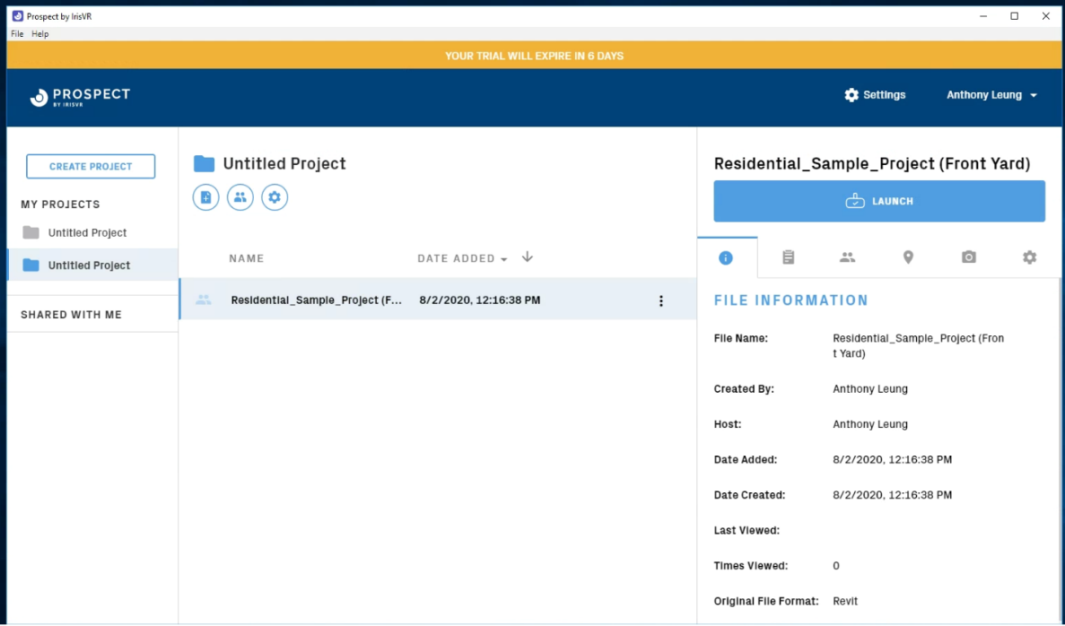

To make it more user-friendly, it should be integrated in the cloud platform of Control Room (such as the BIM 360), so that when all the project team members access to the cloud platform, they can open the model file and then press one button to access the immersive VR environment for walkthrough and remote meeting immediately rather than installing external software and so many steps to start with the visualisation with VR.

# Dashboard

# Case Study: Safety Data to identify critical safety record

A dashboard has been developed based on the modified data sourced from HSE. It is an interactive dashboard to visualise the details of the safety accident record across 2012 to 2017.

In the first dashboard, we can identify the trend that the number of accidents is decreasing across the years and Area B with the highest number of accidents. One can choose whatever categories under different indicators such as “severity”, “age band”, “main activity”, “Risk Category” and “Injury Type” so that the total number of fatalities, incidences and the number of accidents across different years will be changed. It is easy to identify most of the accidents belongs to the activity of M&E installation , category of risk with slip or trip on the same level, workers suffering from body parts such as lower limb and the age band susceptible to accident belongs to 25-34. According to these messages provided by the data via the dashboard, the project managers can make decision like paying more attention to the activity of M&E installation and putting more training to the workers aged with 25-34.

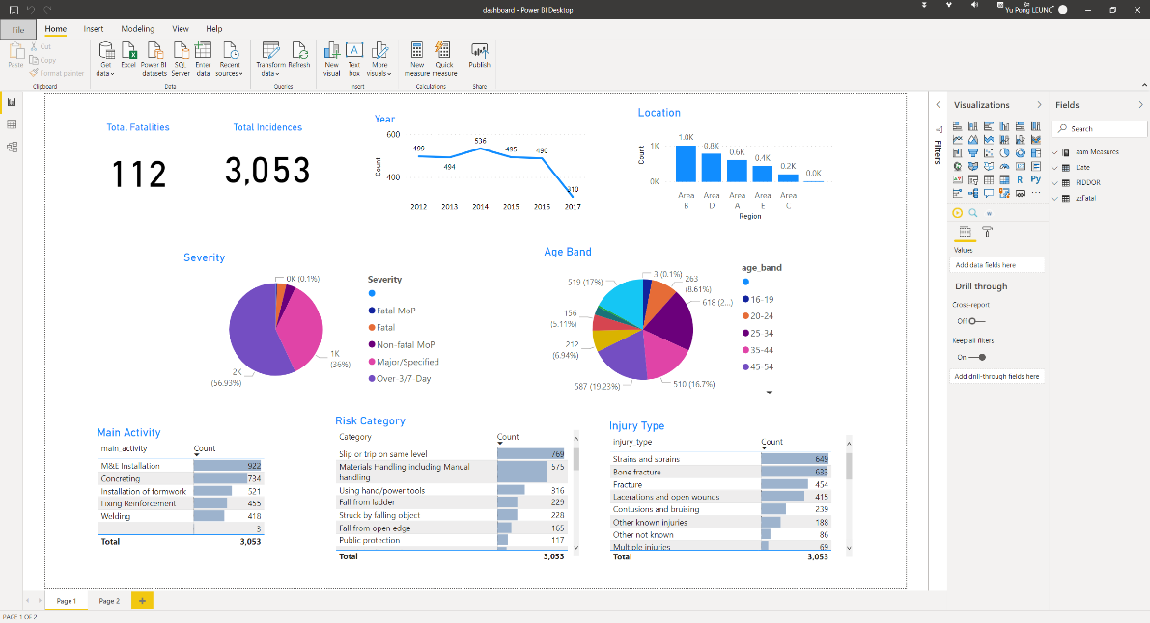

Edward Tufte advice on some critical analysis on the communication of information and the challenges of information visualisation and bias

Besides, the second dashboard use a tree level diagram to visualise the number of accidents. The tree diagram separated into different levels, the first one is “severity”, second is “injury type”, third is “location” and the last one is “main activity”. For example, when we selected one of category under the first level “severity”, then the number of accidents will be separated into different groups under the second level “injury type’”. And then it will separate into different groups under the third level “Location”, when we click one of the group, the number of accidents will be separated in different groups again under the forth level ‘main activity’, so that we can identify the number of accidents based on different level of a specific root.

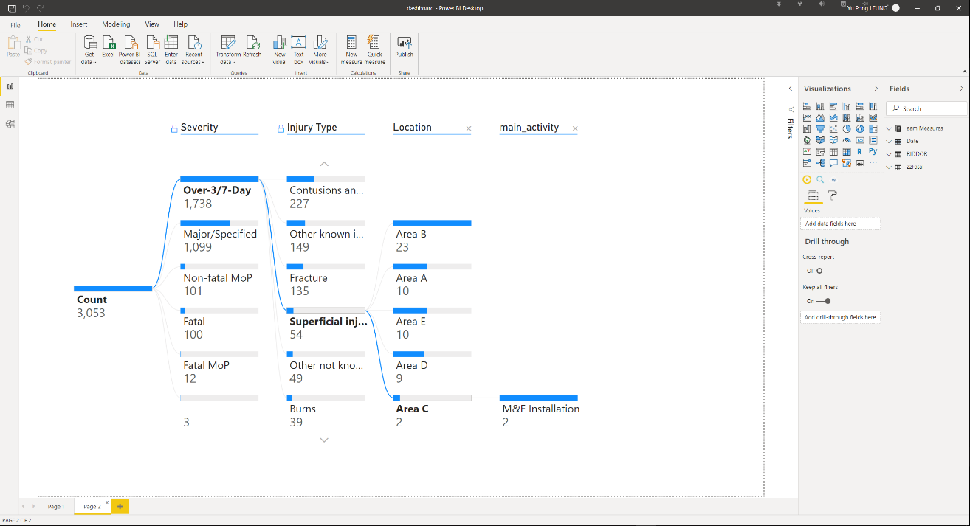

# Limitations

The Power BI is a great platform to present the data to give insight, patterns or abnormality. However, as AEC Sector is a complicated and complex industry, it is quite difficult to standardize a database schema format for data visualization. Since different construction company will have their own standard and indicators to report their project safety, progress related issue and workflow for quality assurance process. As a result, the dashboard function of the control room platform should be highly customizable so that the user can manually edit the schema so that they can keep track on the indicators they want. (Use Open API to solve this problem said of literature?)

Besides, some users may still want to use the Power BI dashboard for data visualization rather than developed this function for the control room platform. However, its integration capabilities with other applications must be improved for a better experience. Originally the Power BI dashboard can be integrated with the BIM 360 cloud platform, so that the construction professional can understand the condition of the BIM model and the project data at the same time. However, Microsoft have changed their data security policy recently so that they don’t allow the user to publish the Power BI dashboard to the websites and other external software. It makes the integration between the Power BI and other platform not in a convenient way. One of the solutions is that the Control Room platform should be at least able to open and interpret the Power BI “.pbix” file so that the construction processionals can just upload the Power BI document to their Control Room platform so that the dashboard can be integrated.

# Web Viewer

# Description of sensory data

Overall, xxx data points were collected from [date]. The range of different parameters is tabulated as below:

|  |  |
| --- | --- |
| **Parameters** | **Range** |
| Temperature |  |
| Humidity |  |
| CO2 |  |
| PM2.5 |  |

# Visualisation of sensory data

As the forge API is not very user friendly and not so many documentations available on the internet, the web viewer is not a completely ﬁnished product, but it shows the majority of the functions it could have.

The web viewer is as shown on the below figure. There is a toolbar below the 3D model for the users to navigate the model such as rotating the model or dragging for translation of model data. Besides, there is a property panel so that the user can find out the property information for each of the elements inside the model. For example, ……

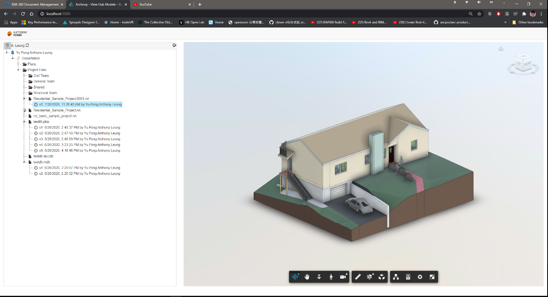

Besides, the sensor data such as humidity/temperature is visualised with the JavaScript library Chart.js/d3. It can dynamically display sensor readings with the changing frequency of 10 seconds.

(chart)

# Functionality for Construction Professionals

To test whether the working condition is safe and healthy for the workers.

# Limitations

**maybe try and think about why Forge was difficult to use and why other approaches were easier - do a compare and contrast to try and think about what needs to improve in forge to make it a viable building block in the system**

The forge API is not easy for the beginners to use. Although Autodesk can already provide different documentation on the internet, it is highly fragmented and not easy to start with. Also, some of the coding document to modify the content of the viewer application suggested from documentation which is only for the old version of the viewer application. For example, the author wants to customise the property panel of the viewer application to add customised content such as the sensory data but it is not successful.

Regarding to this issue, a visual programming interface is suggested so that the user can make use of this API to link the data or get data from other external application easily. The Author originally want to integrate the sensory data into the digital model for visualisation, however, it is very difficult to carry out this task and very less documentation to explain how to do it. As a result, the author used external library to visualise the sensory data. As capturing data by IoT device is becoming much popular, the Control Room platform should provide an easier way to integrate both the sensory data with the model data for visualisation.

# How all the things combined together as an ensemble

illustrate how a day to day-basis would work based on your ensemble

# Limitation (500)

Although this study shows the ability of how the overall Control Room system to improve the project delivery, there was some limitation for this study.

# Recommendation (Link to Intro, LR)

-Talk more about how the integrity can be improved

=> forge is difficult to use, less documentation

=> Power BI cannot insert as card on the BIM360 platform

=> BIM360 shd with plug-in to display the sensory data /SQL data

=> weak in support external data such as sensory data

# Future works

=>Automation / Analysis

Standised process of a control room can manage to five a good building process to build a connected city.

# Conclusion (Link to Intro, LR)

While BIM benefits the delivery of buildings by providing greater efficiencies at all stages of a project lifecycle, VR offers the possibility to explore the human elements of architecture, the form, space and aesthetics of buildings, through an immersive experience (Corke, 2016). Although still in its early days, VR has shown extensive benefits to bring to the architecture and construction industry, from functional and aesthetic evaluation of projects to daylight and lighting studies as well as client collaboration and communication (Corke, 2017).

Through a literature review, it was found that only a handful of available VR applications for architecture and construction uses have been reviewed.

To provide more comprehensive and detailed review on the functionality of a Control Room, this study evaluated multiple functionality that were available on the market recently. Application such as BIM 360, Prospects, Autodesk Forge API, Microsoft were identified and evaluated.

Their capabilities were evaluated including collaboration, information management, ease to use, forms of visualisation, insight as well as license cost.

Recommendations were given on how architecture and construction firms at different levels of interest in VR can apply these applications more effectively.

This study provides a first-hand review to AEC industry who are planning to build a control room platform.

# Reference

Alizadehsalehi, S., Hadavi, A., & Huang, J. C. (2019). Virtual reality for design and construction education environment. *AEI 2019: Integrated Building Solutions - The National Agenda - Proceedings of the Architectural Engineering National Conference 2019*. https://doi.org/10.1061/9780784482261.023

Belizario, M. G., & Berardi, R. C. G. (2019). Use of Smart and Open Data in Smart Cities. In *25th Americas Conference on Information Systems (AMCIS 2019)*.

Bennett, S. (1993). A History of Control Engineering 1930-1955. In *A History of Control Engineering 1930-1955*. https://doi.org/10.1049/pbce047e

Boje, C., Guerriero, A., Kubicki, S., & Rezgui, Y. (2020). Towards a semantic Construction Digital Twin: Directions for future research. In *Automation in Construction*. https://doi.org/10.1016/j.autcon.2020.103179

Brandon, J. (2020). *VR is the future of remote working*. https://www.techradar.com/news/vr-is-the-future-of-remote-working

Changali, S., Mohammad, A., & Van Nieuwland, M. (2015). The construction productivity imperative. *McKinsey Quarterly*.

Engineers, I. of C. (2018). *P13 Blue Print*.

Freina, L., & Ott, M. (2015). A literature review on immersive virtual reality in education: State of the art and perspectives. *Proceedings of ELearning and Software for Education (ELSE)(Bucharest, Romania, April 23--24, 2015)*. https://doi.org/10.12753/2066-026X-15-020

HSE. (2019). Work-related stress , anxiety or depression statistics in Great Britain , 2019. *Annual Statistics*.

Jarrett Hendricks. (2020). *Rise of the Digital Twin: How Lessons Learned from NASA Are Changing the Way Supply Chains Are Managed*. https://info.expeditors.com/horizon/rise-of-the-digital-twin

Keil, S., Lasch, R., Lindner, F., & Lohmer, J. (2019). *A Holistic Digital Twin Based on Semantic Web Technologies to Accelerate Digitalization*.

Lara, A. P., Da Costa, E. M., Furlani, T. Z., & Yigitcanlar, T. (2016). Smartness that matters: Towards a comprehensive and human-centred characterisation of smart cities. *Journal of Open Innovation: Technology, Market, and Complexity*. https://doi.org/10.1186/s40852-016-0034-z

Levine, T. (2016). *Using Communication and Collaboration Technology to Keep Construction Projects On Schedule and On Budget*.

Li, X., Yi, W., Chi, H. L., Wang, X., & Chan, A. P. C. (2018). A critical review of virtual and augmented reality (VR/AR) applications in construction safety. *Automation in Construction*. https://doi.org/10.1016/j.autcon.2017.11.003

McKinsey. (2015). The MGI Industry Digitization Index. *McKinsey Global Institute*.

McKinsey & Company. (2017). Reinventing Construction: A Route To Higher Productivity. *McKinsey & Company*.

Microsoft. (2020). *Azure Cloud Services*. https://azure.microsoft.com/en-us/overview/what-is-cloud-computing/

Mohd Nawi, M. N., Baluch, N., & Bahauddin, A. Y. (2014). Impact of fragmentation issue in construction industry: An overview. *MATEC Web of Conferences*. https://doi.org/10.1051/matecconf/20141501009

StarCompliance. (2019). *Compliance Control Room: What Is It And Who Needs It?* https://blog.starcompliance.com/control-room-what-is-it-and-who-needs-it

Stergiou, C., Psannis, K. E., Kim, B. G., & Gupta, B. (2018). Secure integration of IoT and Cloud Computing. *Future Generation Computer Systems*. https://doi.org/10.1016/j.future.2016.11.031

Woodhead, R., Stephenson, P., & Morrey, D. (2018). Digital construction: From point solutions to IoT ecosystem. *Automation in Construction*. https://doi.org/10.1016/j.autcon.2018.05.004

Xu, S., & Luo, H. (2014). The information-related time loss on construction sites: A case study on two sites. *International Journal of Advanced Robotic Systems*. https://doi.org/10.5772/58444

Yi, Y., Yan, Y., Liu, X., Ni, Z., Feng, J., & Liu, J. (2020). Digital twin-based smart assembly process design and application framework for complex products and its case study. *Journal of Manufacturing Systems*. https://doi.org/10.1016/j.jmsy.2020.04.013

# Research Log

# Appendix

Coding, github